**Buck-Boost Converter Data**

**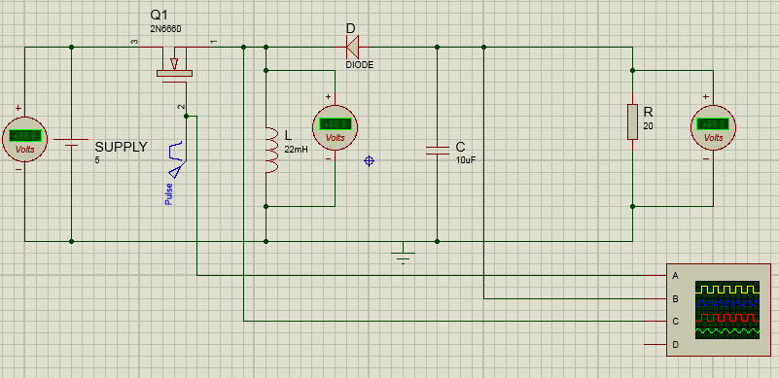  
Figure 1: Proposed Buck-Boost converter circuit**

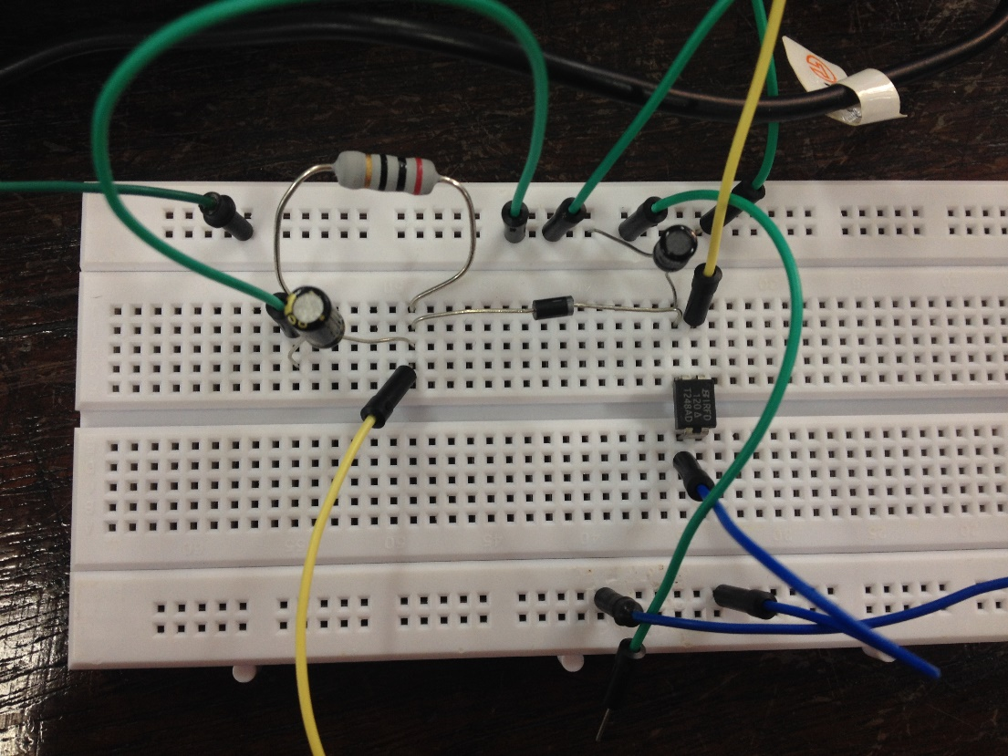**The oscillator is connected to Pulse Generator (yellow), the voltages across inductor, VL (red) and capacitor, VC (blue).**

**VD: 5V**

**VG: 8V**

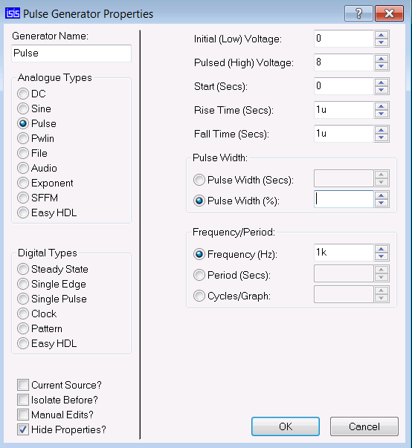**Figure 2: Values are set for of trise, tfall and Frequency**

|  |  |
| --- | --- |
| **Duty Cycle** | **VL** |
| **30%** | **(Buck)** |
| **50%** | **8V** |
| **80%** | **(Boost)** |

**Table 1: Output VL for 30% of duty cycle at the gate**

**Circuit setup with Intel Edison**

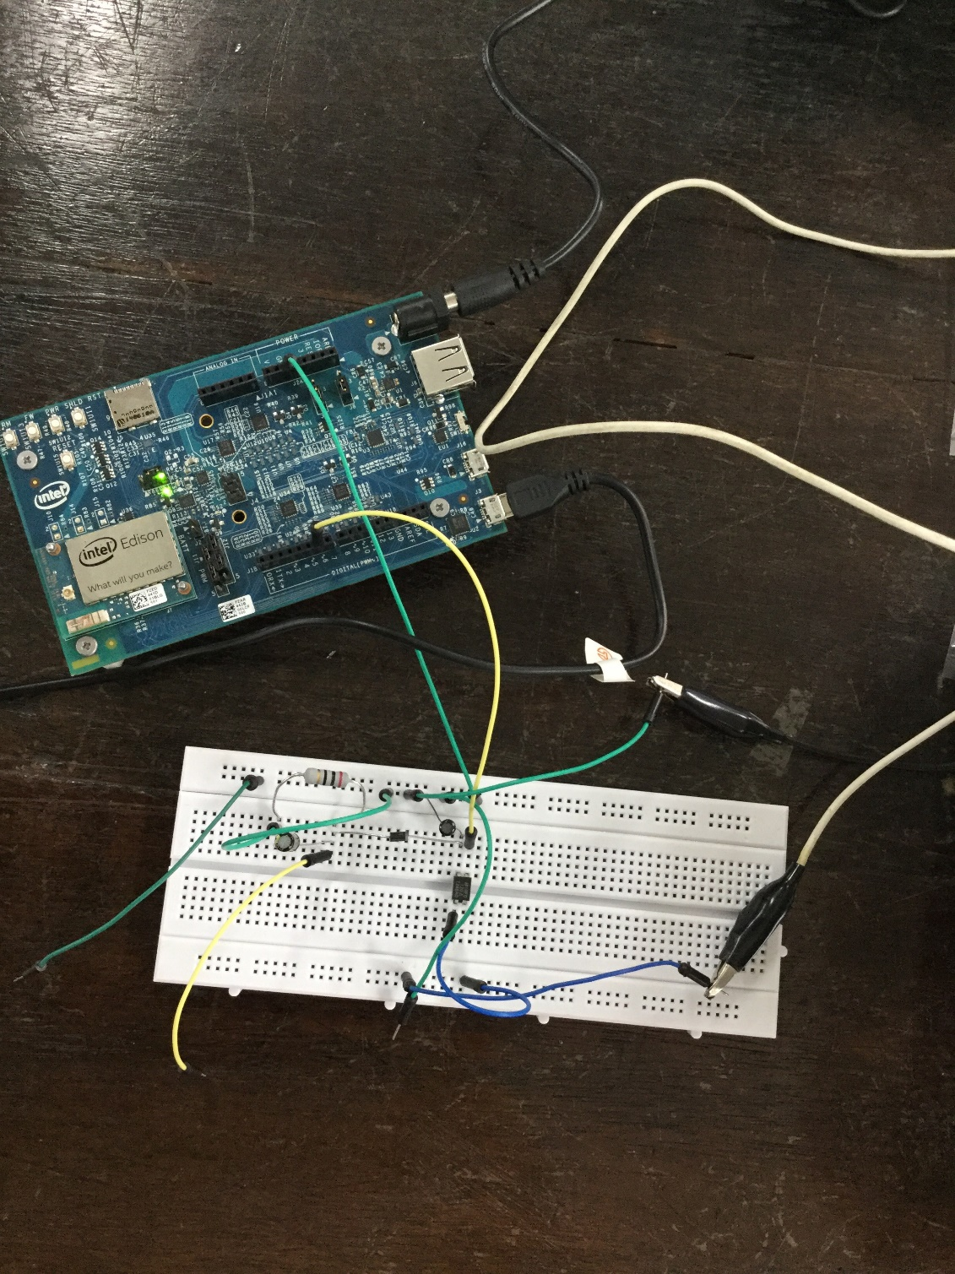

**Activity 1: set 30% duty cycle Edison PWM**

**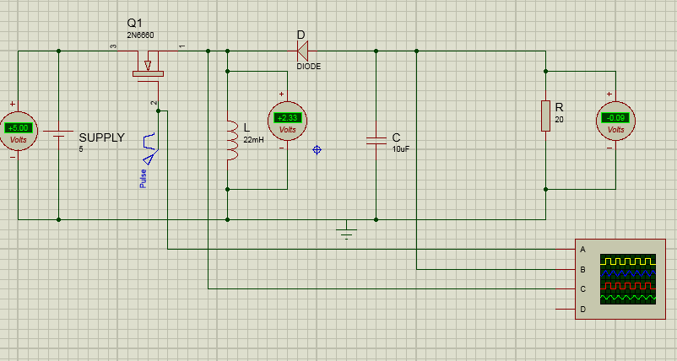  
Figure 3: Output voltage across the inductor, VL for 30% duty cycle  
  
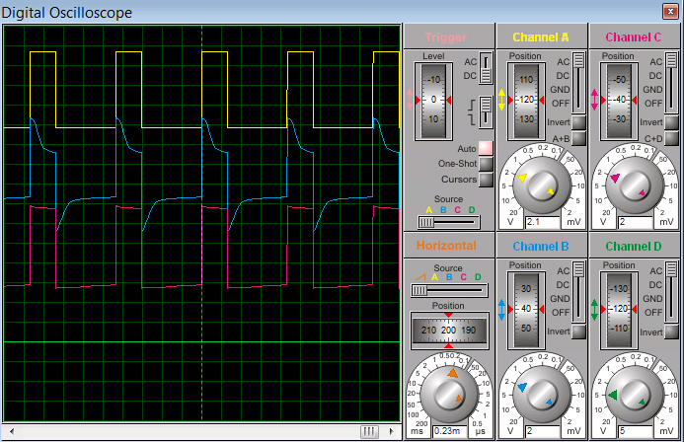  
Figure 4: Example Output waveform for 30% duty cycle**

**Expectation observation: Input, 30% duty cycle**

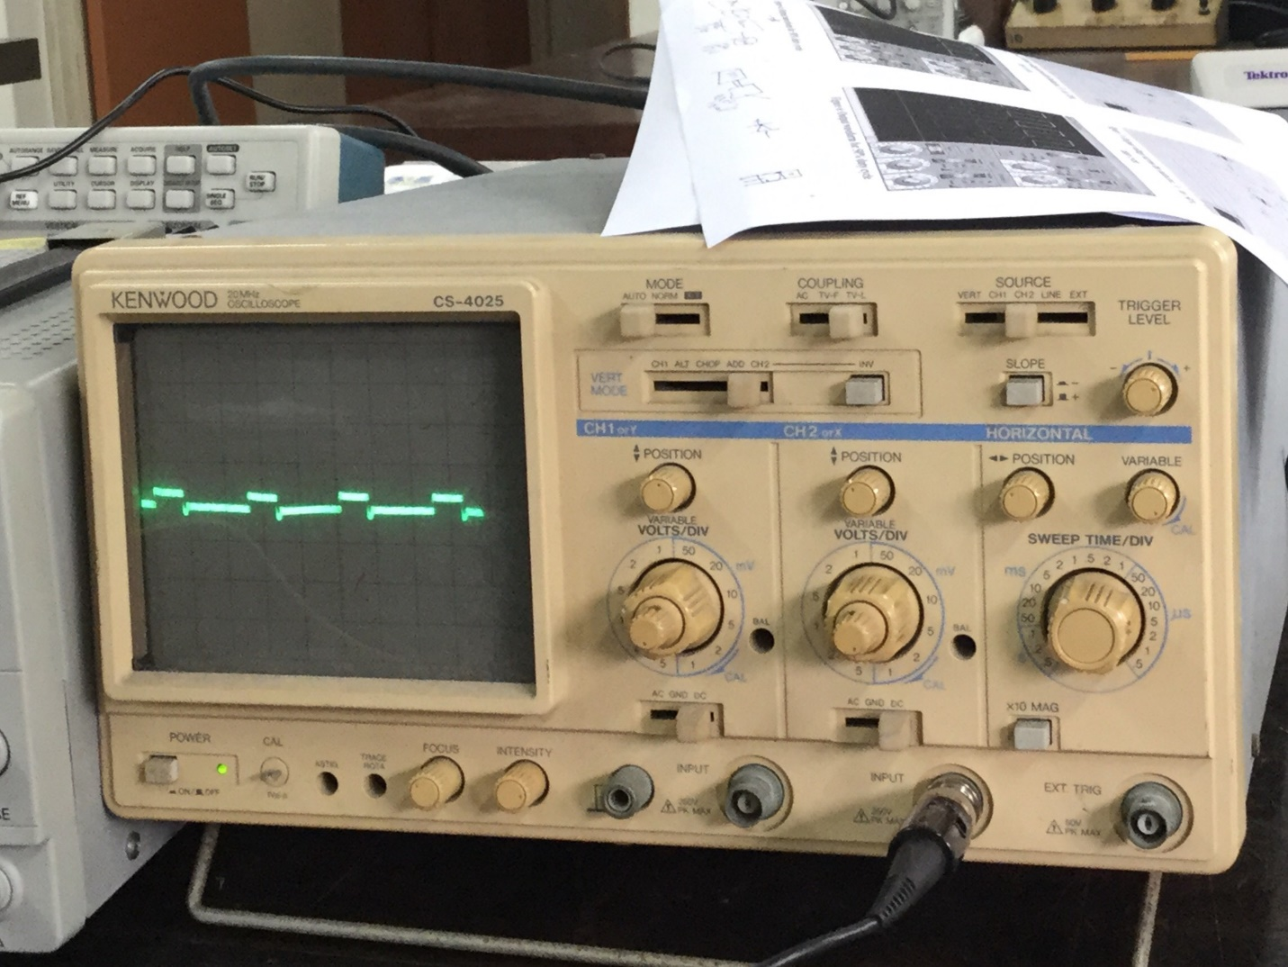

**Code testing**

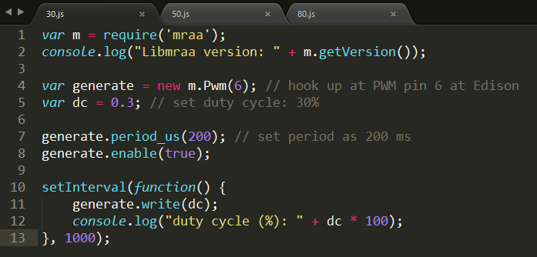

**Activity 2: set 50% duty cycle Edison PWM**

**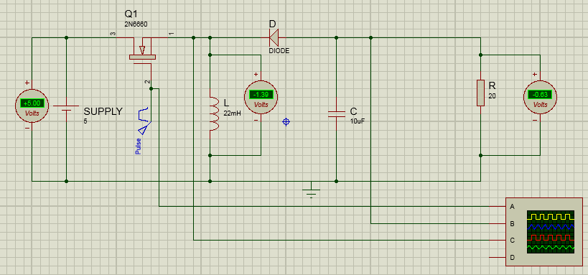  
Figure 5: Output voltage across the inductor, VL for 50% duty cycle**

**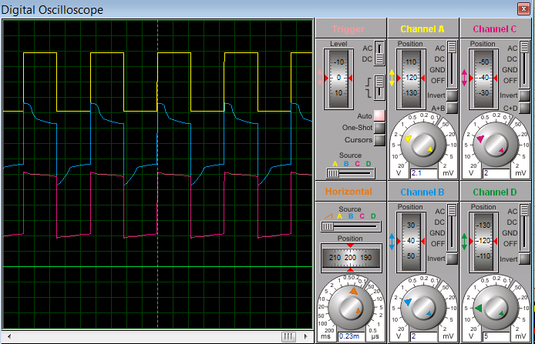  
 Figure 6: Example Output waveform for 50% duty cycle**

**Expectation observation**

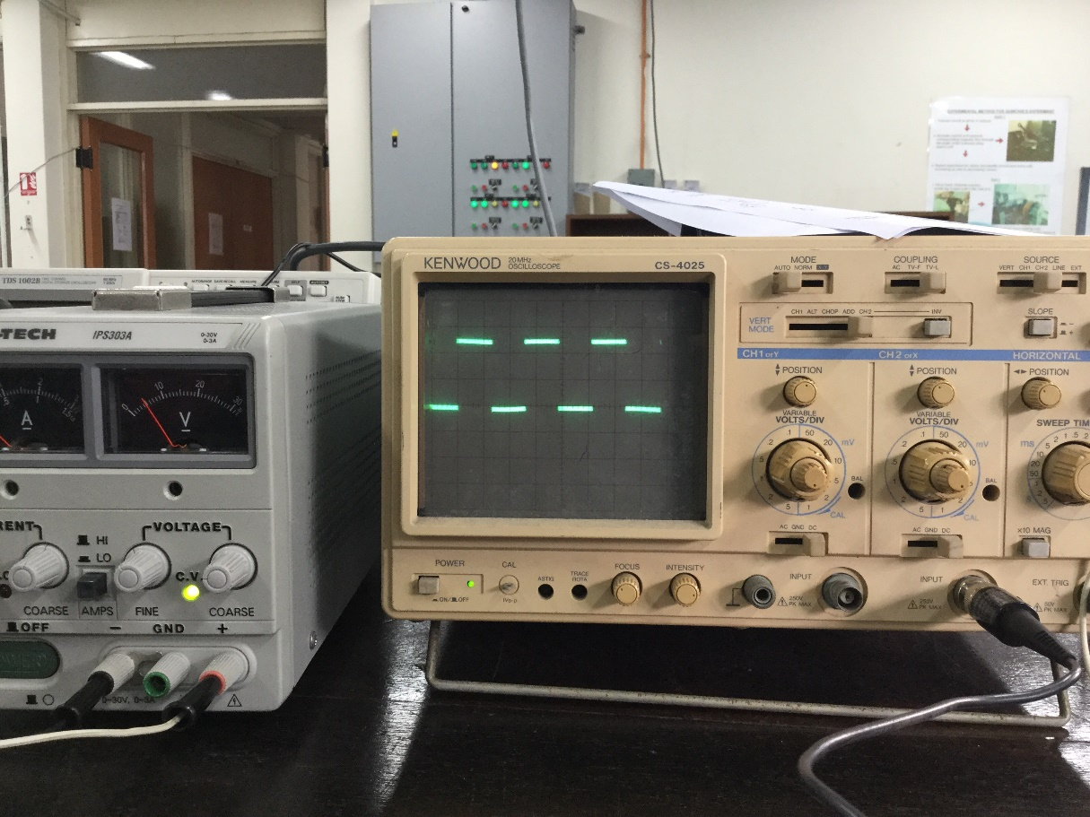

**Code testing**

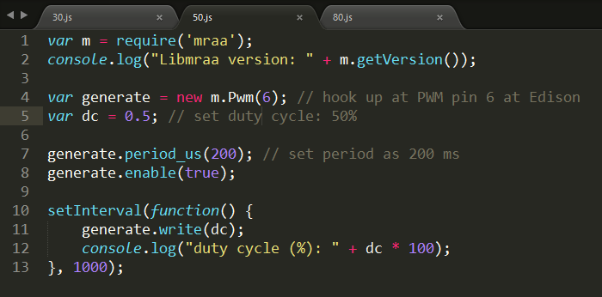

**Activity 3: set 80% duty cycle Edison PWM**

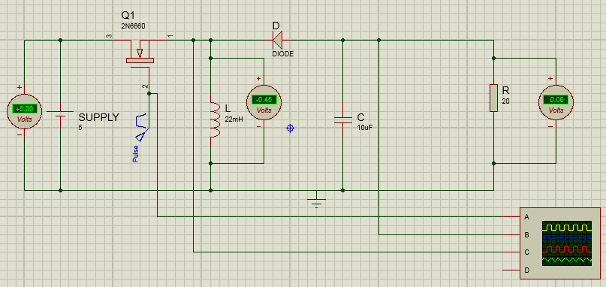 **Figure 7: Output voltage across the inductor, VL for 80% duty cycle**

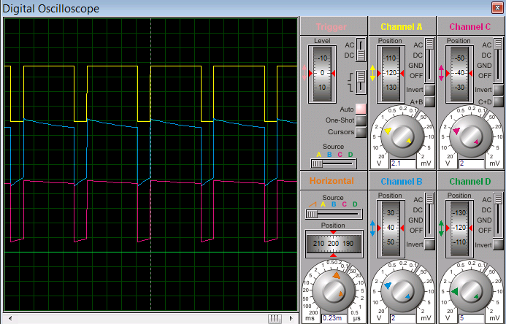

**Figure 8: Sample Output waveform for 80% duty cycle**

**Expectation: Input, 80% duty cycle**

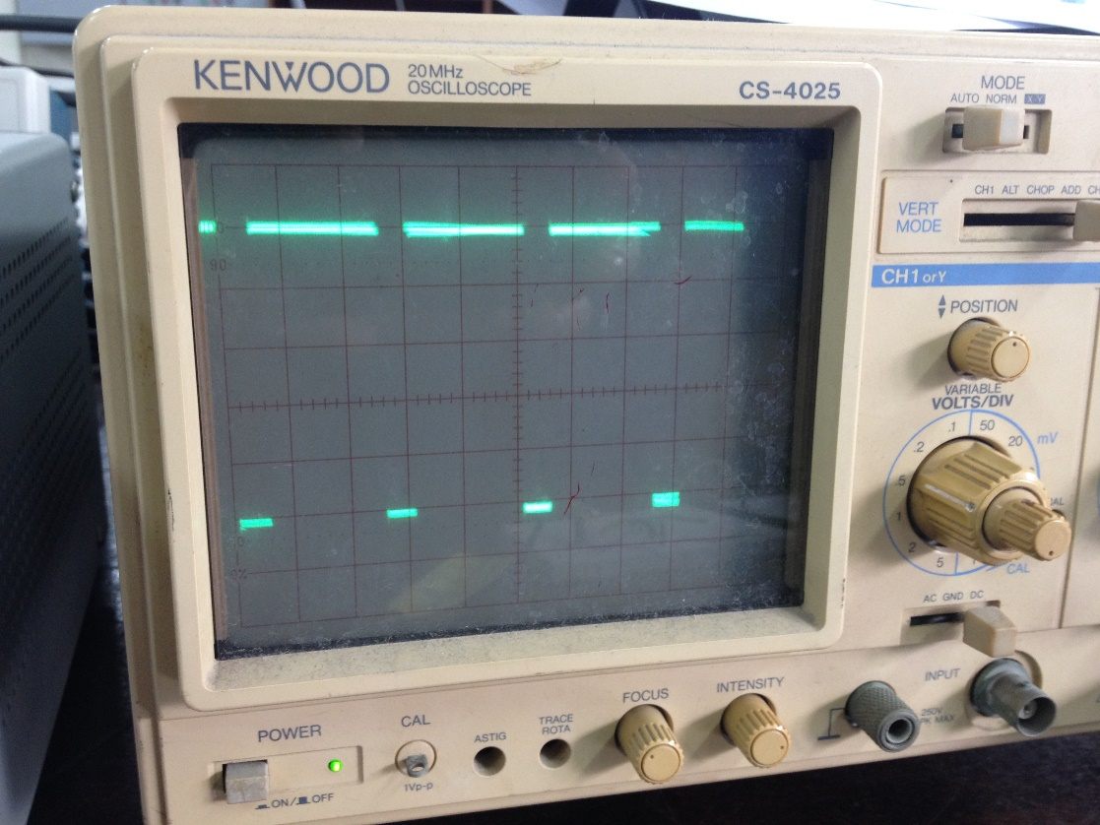

**Expectation: Output, 80% duty cycle**

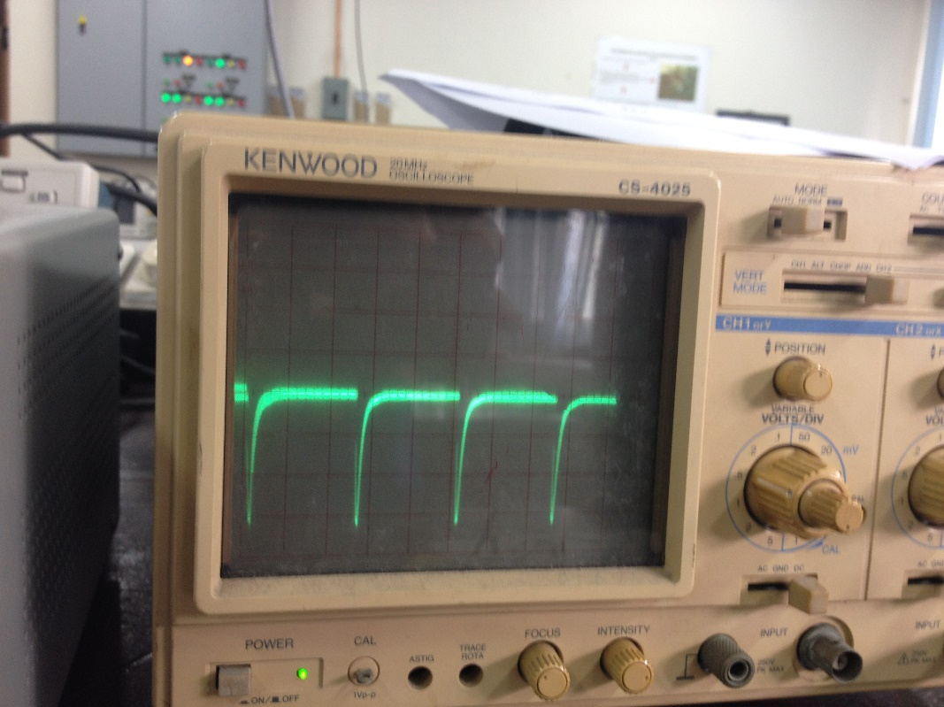

**Code testing**

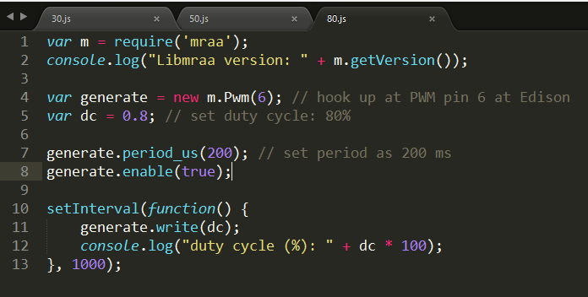

**Prepared by : Prof. DR. Ishak Aris and Syed Khairil Syed Kharuddin  
Modified by: Hadrihl**